**Consume a custom vision model**

**Test the custom model in Vision Studio**

Once you've built a custom model, you can test by selecting the **Try it out** button on the model evaluation screen.

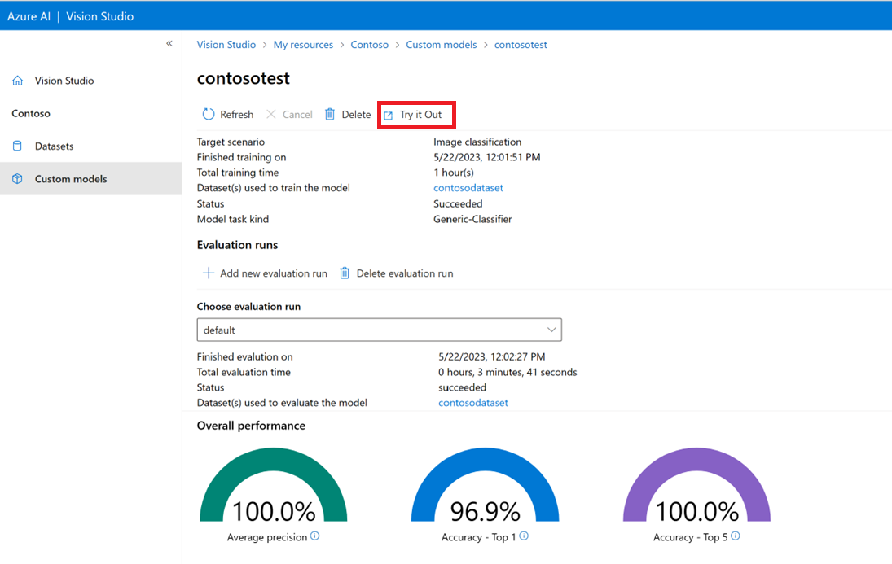

This takes you to the **Extract common tags from images** page. Choose your custom model from the drop-down menu and upload a test image.

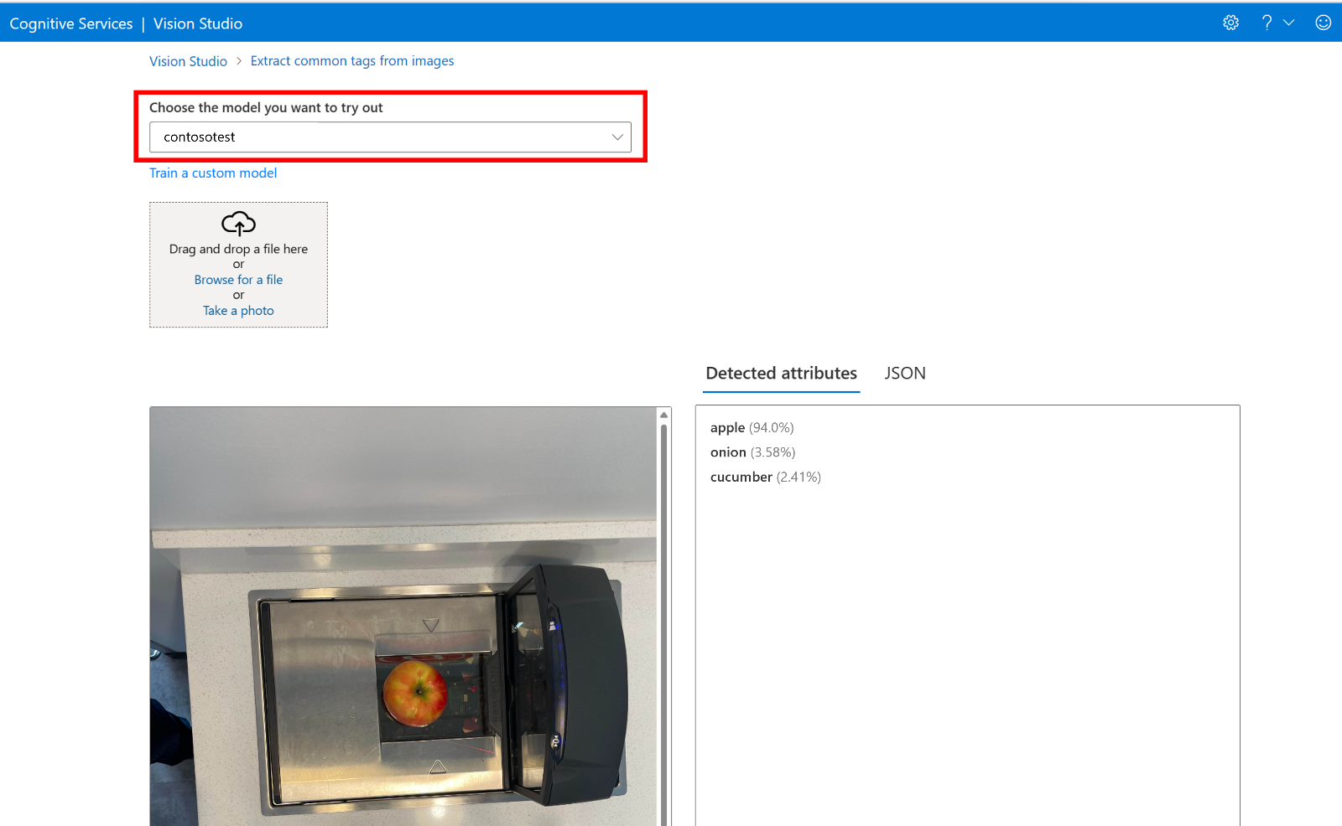

The prediction results appear in the right column.